**Disable an EID**

1. Using EID Provisioning by click (only EID Access Administrator can login this link) <https://extranet.marriott.com/eap/manageaa/FranchiseeEIDProvisioning/default>
2. Click
3. Select the EID you want to shutdown
4. Clickagain, and then submit a work exit request form immediately. 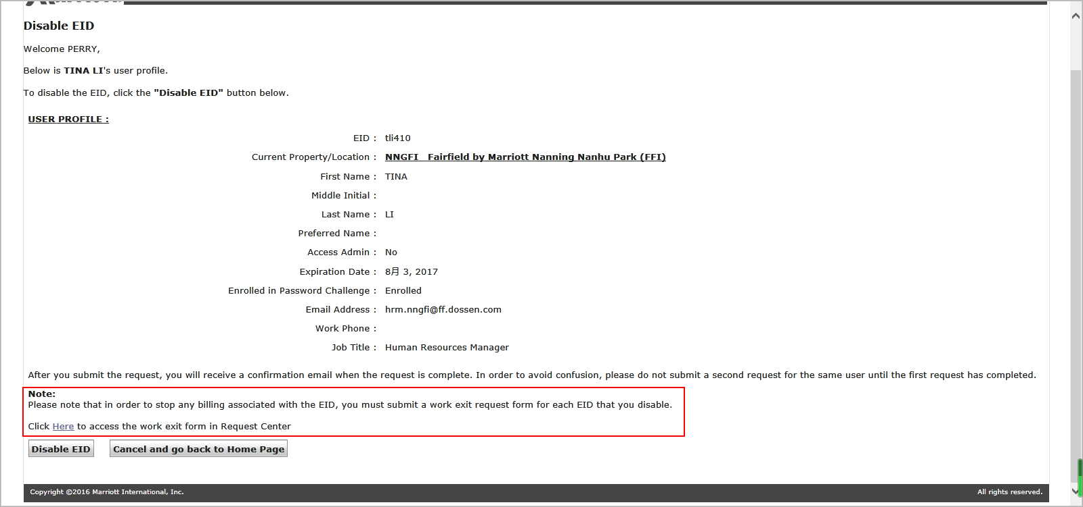
5. Go to Request Center(no using EID approver, HR’s EID is suggested) <https://extranet.marriott.com/sdm/RequestCenter/docs/QuickLinksView.html>
6. Select
7. Click ‘Search’ for a customer(customer is one who you want to disable) 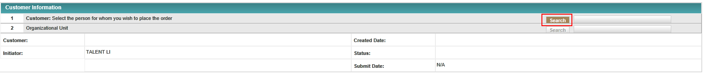
8. Click ‘Search’ again after typing the required field
9. Select the right result and then click ‘OK’ 
10. Select ‘Search’ for a Service by typing ‘work exit’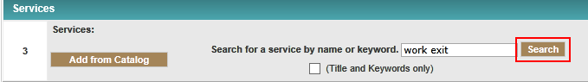
11. Select the second one and place ‘Order’ 
12. Fill in the form as follow, please note the highlighted question as necessary. 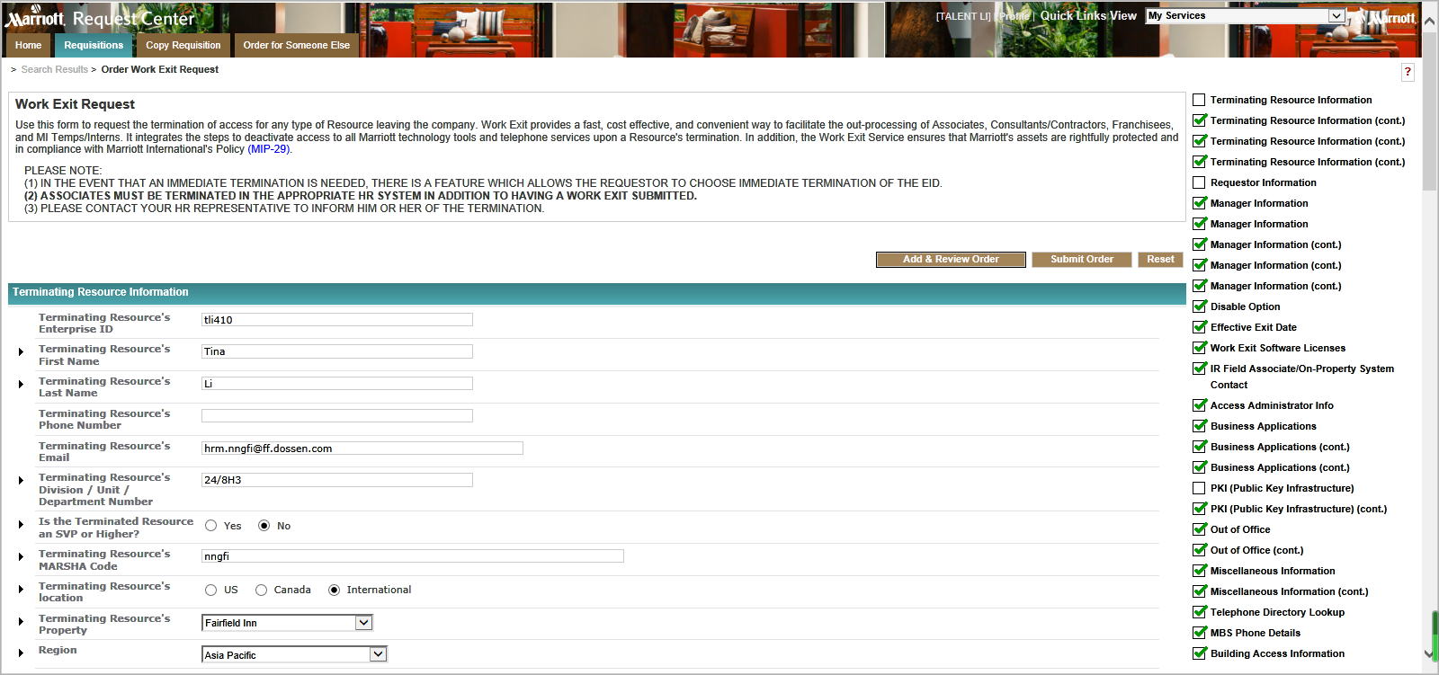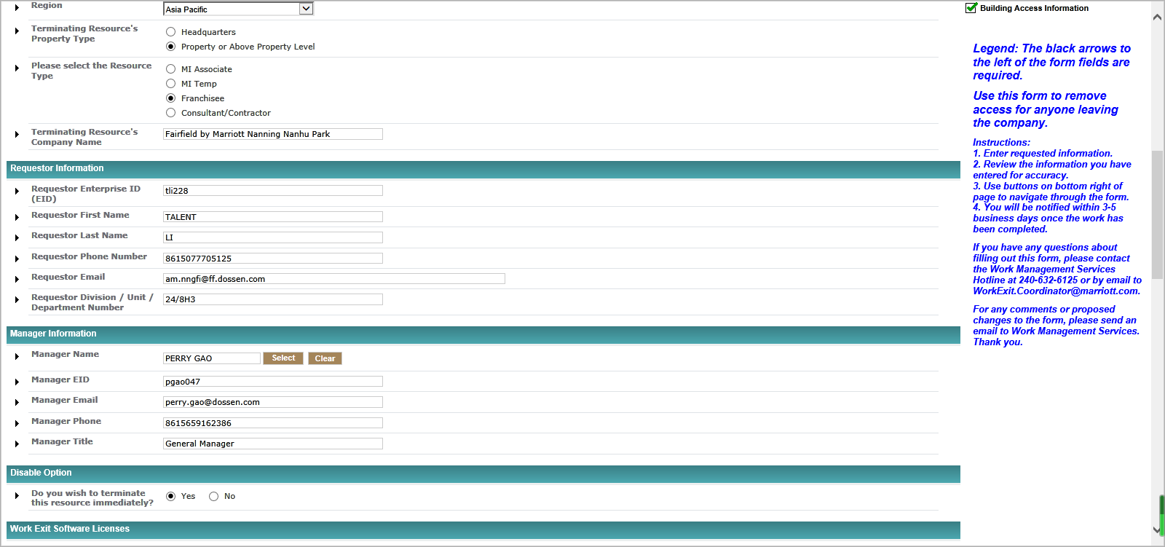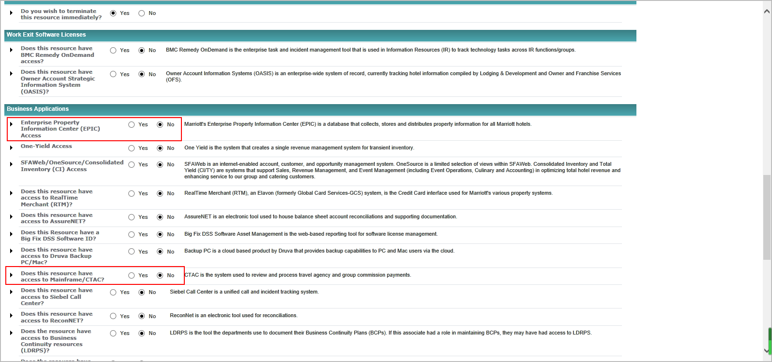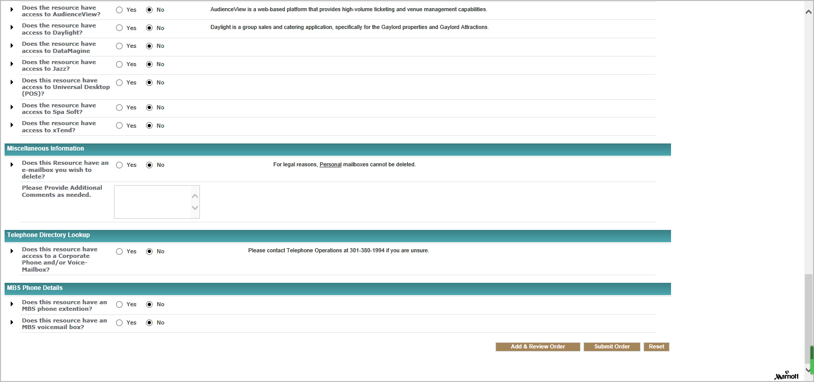
13. Submit Order
14. Click ‘continue’ to finish.